Aaditya Rai

Minesweeper User guide

IS1101

37232815

Contents

Introduction 2

System Requirements 2

Installation Guide 2

Playing the game 3

Startup Form 3

Game Form 5

Scoring Form 9

Tips 11

Troubleshooting 11

# Introduction

Minesweeper is a single player strategy and puzzle game. This user guide instructs you how to install and play Minesweeper. Additionally, it outlines the system requirements, tips and troubleshooting help.

# System Requirements

* Mouse and keyboard
* 1.8 GHz or faster 64-bit processor
* 1 GB RAM(recommended minimum)
* Windows 10 later
* 1024x768 resolution (recommended minimum)

# Installation Guide

1. Find the downloaded zip file. It is called *Rai Aaditya Stage 2* and is most likely in your downloads folder.
2. Right click on the zip and click the ‘Extract All’ option.
3. Find the extracted file
4. Go to *Downloads (or wherever your file is located)\Rai Aaditya Stage 2\.* The user guide is located in this folder. To find the Minesweeper.exe follow file path: *Downloads (or wherever your file is located)\Rai Aaditya Stage 2\bin\Debug\net6.0-windows* and click on the exe file to run the game

# Playing the game

## Startup Form

Upon start-up of the game you will see the start-up screen pictured below. Enter your name, and select your difficulty in the relevant areas. Click play to start the game.

The difficulty determines the size of your playing grid:

|  |  |
| --- | --- |
| Difficulty | Specifications |
| Beginner | 9x9, 10 mines |
| Intermediate | 16x16, 40 mines |
| Expert | 30x16, 99 mines |

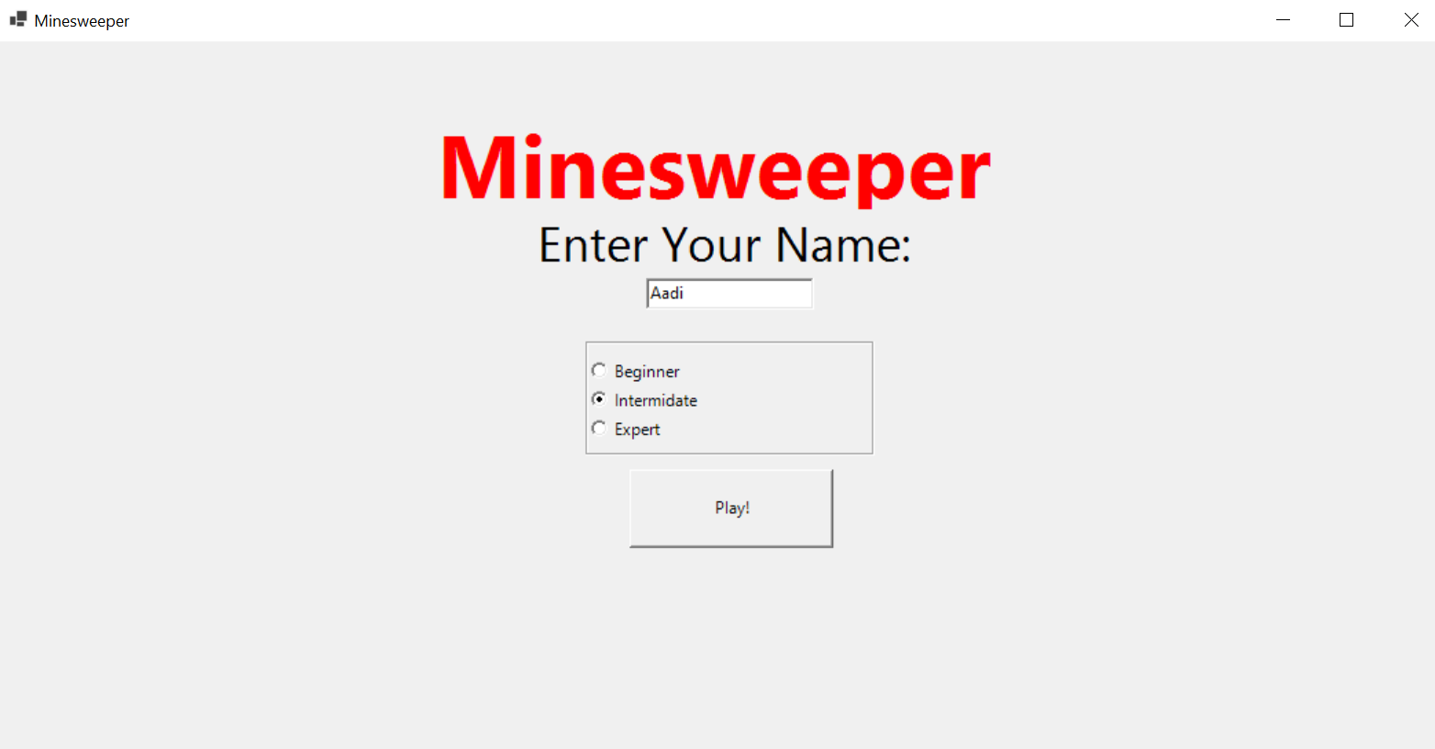

Above is what your screen should look like (with your own name and desired difficulty). After completing the first two steps press play to get started!

## Game Form

This is the game form, where you are taken after clicking the play button. The game form consists of the playing grid (which varies in size according to your difficulty), and a menu bar which shows your name and tracks your progress.

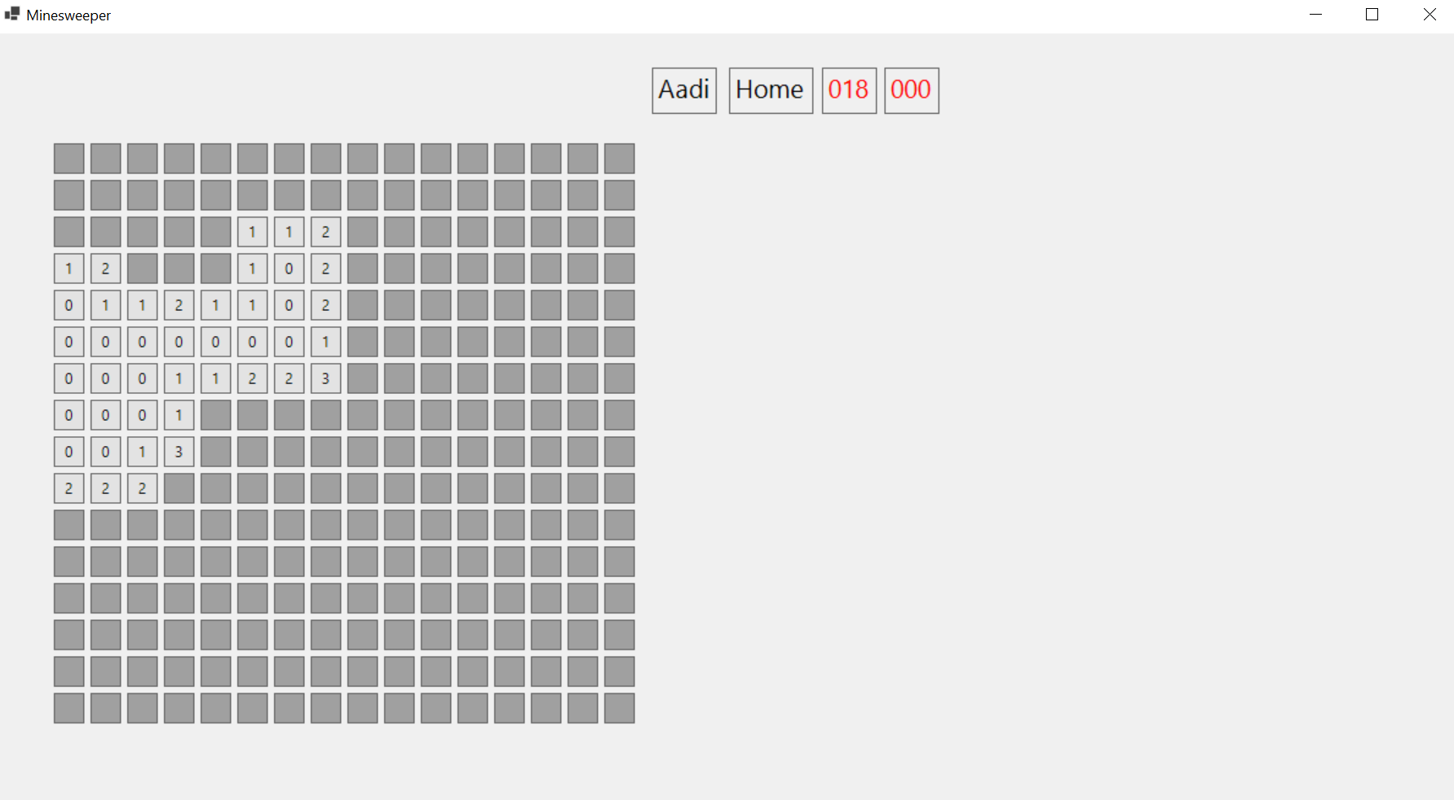

Click anywhere to start the game. Don’t worry you can’t hit a mine on your first turn. The light grey squares represent grids that have been uncovered, and the numbers in them show how many mines that grid is touching. The dark grey squares are uncovered. If you think you know where a mine is you can right click to flag it. The circled grid is touching 1 mine and there is only one uncovered grid that it is touching, so it must be the mine.

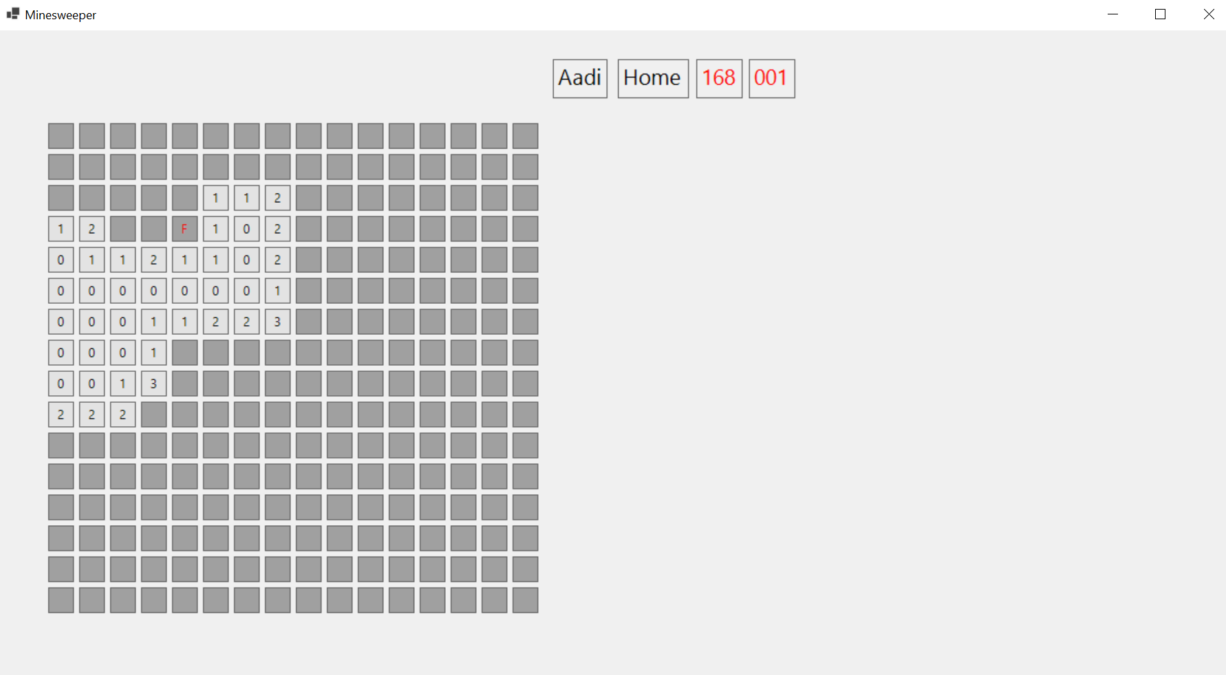

The flagged mine is indicated by a red F. Notice the counter has also increased to show how many mines have been flagged. After flagging the mine you can uncover some grids based on that knowledge.

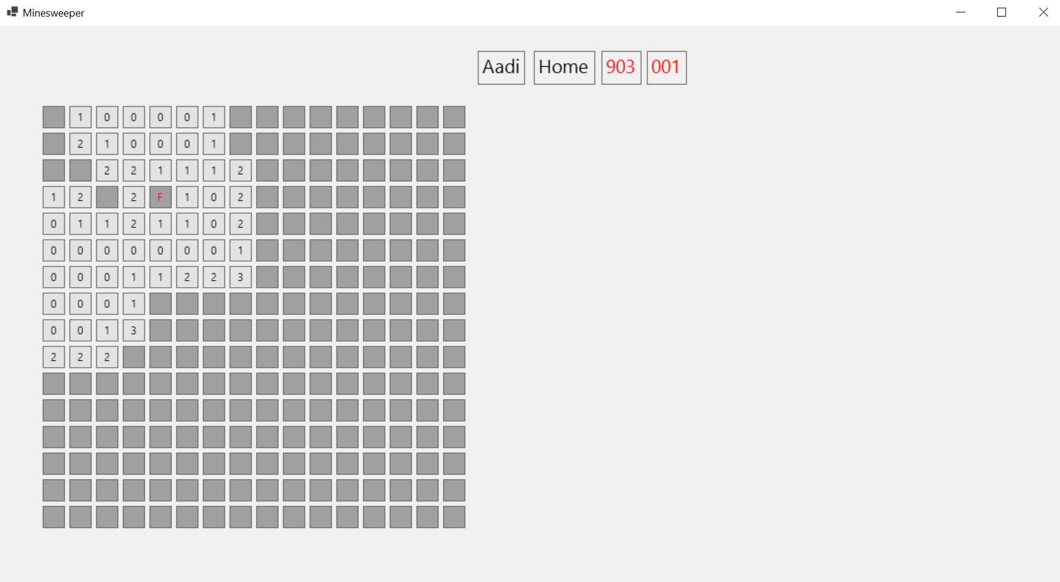

Continue this process of flagging mines and uncovering grids. If you win the game by successfully uncovering (you don’t have to flag all the mines) then you will be taken to a congratulations screen. If you hit a mine you will have lost and also be taken to another screen.

## Scoring Form

This is the form you will see if you win the game. It tells you that you won, shows your game stats, and gives you the option to play again or go home. Clicks taken is the primary method of scoring.

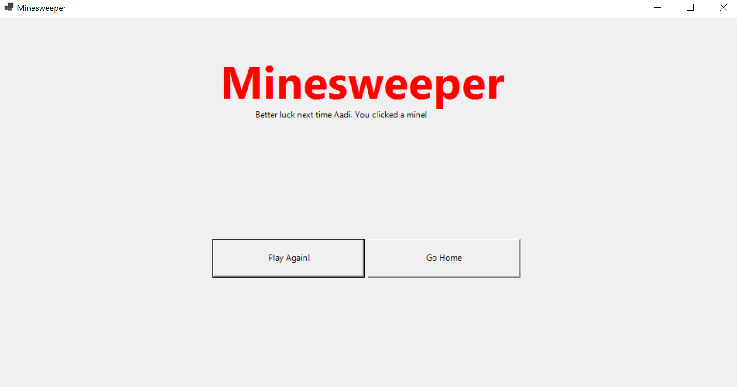

This is the form you will see if you click the mine and lose the game. It tells you that you lost and gives you the same options as the form above; play again or return home.

# Tips

1. Start off with the easy difficulty and move up as you get more experienced
2. Take your time, you don’t get scored on how long you take
3. While you don’t necessarily have to flag mines, they are a good tool to indicate where the mines are.
4. If you get stuck take your time to think, randomly clicking will likely make you hit a mine.
5. Pay attention to how many mines are left, this can be helpful towards the end of the game.

# Troubleshooting

|  |  |
| --- | --- |
| Error | Reason and Fix |
| Warning: Player name must be 2-10 characters long | Your name is too short or too long. Make sure the player name you input is longer than 2 characters but short than 10. |
| Warning: You have not selected a difficulty | You have not indicated the difficulty you would like to play. Make sure one of the radio buttons is clicked. |

For any other support please contact Aaditya Rai: [Aaditya.Rai@cgs.act.edu.au](mailto:Aaditya.Rai@cgs.act.edu.au)